**Liquor Control Board for Harford County, Maryland**

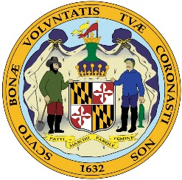

16 North Main Street

Bel Air, Maryland 21014-3780

410-638-3028 ● Fax 410-638-4970

www.hclcb.org

|  |  |
| --- | --- |
| **Notice Type:** | Decision – Change in Class Transfer |
| **Election District:** | 6th |
| **License Class:** | B-BWL-On Sale Only |
| **Applicants:** | Stefanie M. Connor, Member  Santos G. Trejo Coreas, Member  Estefani E. Medrano Trejo, Member |
| **Business Entity:** | Tutti Paella Bar & Grill, L.L.C. |
| **Trading As:** | Tutti Paella Restaurant |
| **Location:** | 2021 Pulaski Highway (Suite H), Havre de Grace, MD 21078 |
| **Application Status:** | Change in Class Transfer Approved |
| **Remarks:** | Class Transferred From: B1-BW-On Sale Only |

Wayne S. Goddard, Chair

Judith A. Powell, Licensing Coordinator